- Problem statement -

Namami Gange Tours and Travel aim to manage the customer bookings. There are constant calls about queries and a proper system for noting down all the queries doesnt exist. This leads to loss of client and reduced referrals. Many customer enquiries require significant manual follow-up, but there is no structured system to track, prioritize, and convert enquiries into bookings.

- Goals and Non-goals -
  - Goals
    - Increase the quality of follow ups by tracking all queries.
    - Ensure all customer enquiries are captured, organized, and trackable from initial enquiry to booking.
  - Non-goals
    - Enquiries with longer decision or travel periods should remain in the tracking system for future follow-up.
    - Remain in the same premium segment company.
    - Building an AI chatbot or AI calling agent as part of this solution.

- Success Metric -

- North Star - Record and track at least 90% of customer enquiries received through calls and WhatsApp.
- L1 - Percentage of enquiries successfully recorded with all required information. Increase the number/percentage of enquiries converted into confirmed bookings through structured follow-ups.
- Counter Metric - % of enquiry records containing inaccurate/incomplete information — target: keep below 5%.

- User Persona
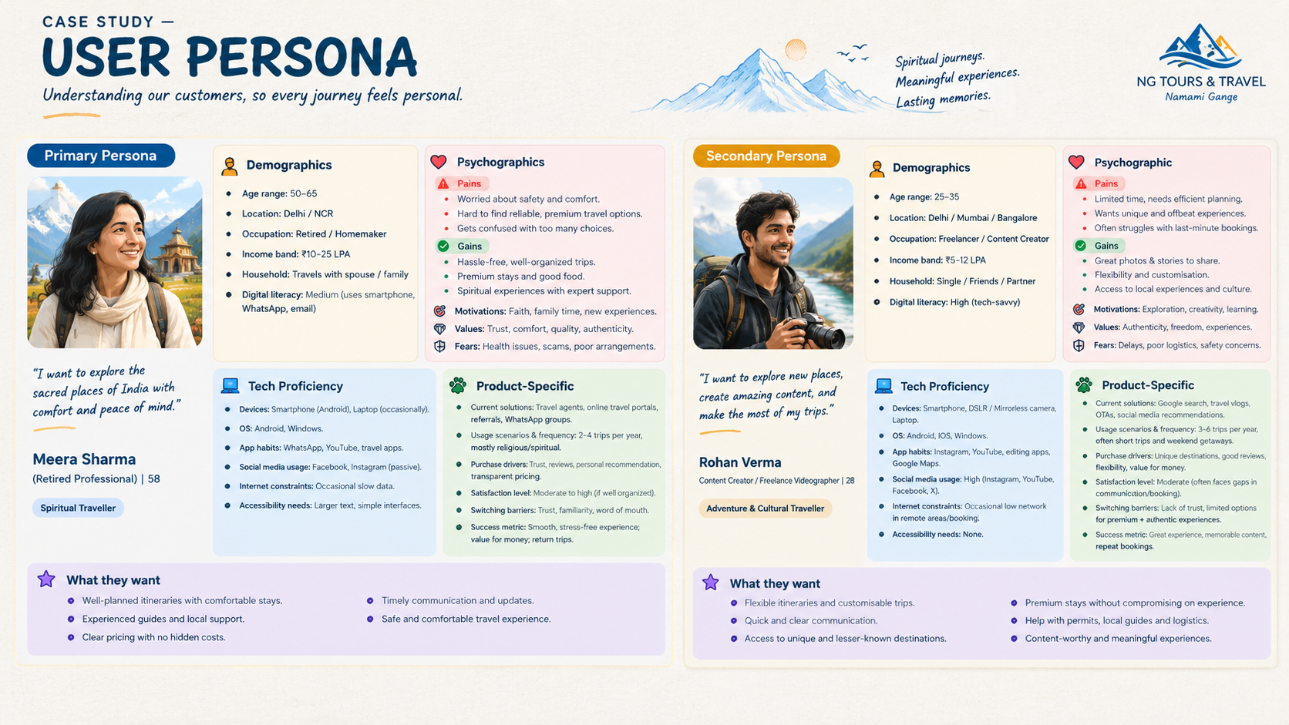

- User Journey -

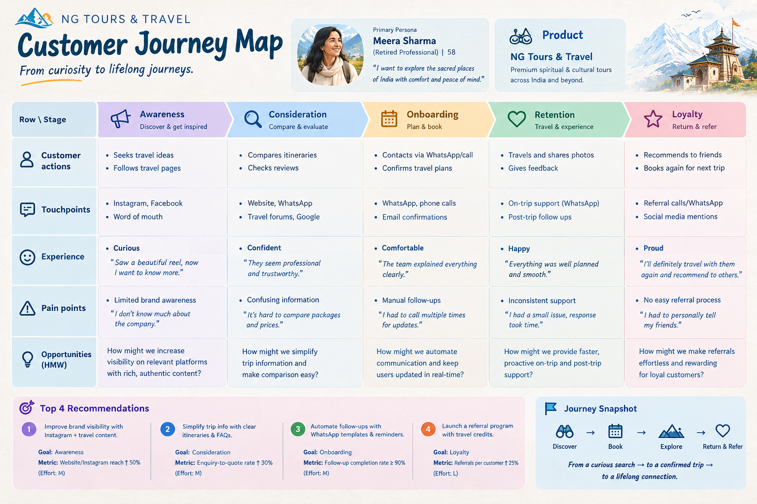

- What are the competitors offering?
- Competitors bring WhatsApp enquiries directly into the CRM instead of manually recording them.
- Competitors let agents create branded itineraries/quotes directly from the customer record and send them through WhatsApp/email.
- Travel CRMs can continue managing payments, vouchers, traveller documents and trip operations after conversion instead of manually making them.

- RICE Framework:

Opportunity | Reach (1–10) | Impact (1–10) | Confidence | Effort (months) | RICE Score
WhatsApp → automatic CRM enquiry capture | High | High | High | Low | High
Branded quotation/itinerary creation | High | High | High | Low | High
Post-booking payments, vouchers & documents | Medium | Medium | High | Low | Medium

- FUNCTIONAL AND ACCEPTANCE CRITERIA / NON-FUCTIONAL REQUIREMENTS
- Functional -
- The enquiry should automatically be captured by the CRM from the whatsapp and the columns must be filled with the relevant context.
- Itinerary must be created alongside the enquiry and the final output will be automatically sent to the customer after being verified by a human.
- Vouchers & related documents must be forwarded to the hotels and the customer.
- Non Functional
- P - Performance - The CRM must capture the data within 10 minutes of interaction.
- Q - Quality - The output generated like the itinerary and vouchers must be in accordance to the company’s format.
- R - Reliability - Any changes made by the customer in date or place must be updated accurately.
- S - Secure - Customer data should be protected against unauthorized access.
- T - Transparency - All data which is being captured by the CRM must be traceable.
- U - Usability - The system should enable at least 80% of the required customer details to be captured within the first two interactions.
- MOCK-UP
- PROTOTYPES (TENTATIVE)
- GITHUB PUSH AS A PORTOLIO

